Carbon County Child Development Programs

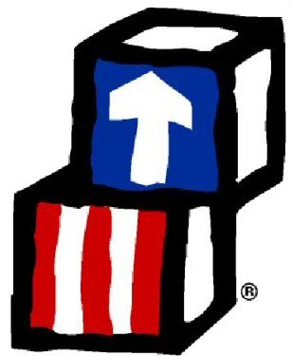
Annual Report
School Year
2022 - 2023

Rawlins
Saratoga

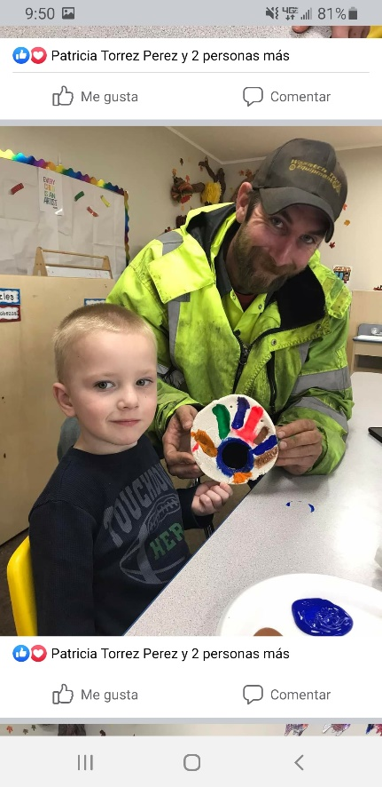
Table of Contents

- Cover Page……………………………………….……………………………………………………………………………1
- Table of Contents…………………………………………………………………………………………………………..2
- Introduction & Thank You...….……………….………………………………………………………………………3
- Mission and Philosophy..………………………………..……………………………………………………………..4
- Governance…..…………………..………………………………………………………………………………………….5
- Rachel’s Challenge..……………………..…………………………………………………………………………….6-9
- Budget.…………………………………….……………………………………………………………………………..10-13
- Health and Nutrition…….…………………………………….…………………………………………………..14-15
- School Readiness and Curriculum…….……………………….…………………………………………….16-21
- Enrollment and Attendance…….…………………………………….………………………………………..22-23
- Families and Volunteers……………….…………….…………………………………………………………..24-30
- Information Page…………………………………….…………………………………………………………………..31
- End Page……………………….…….……………………………………………………………………………………...32

Carbon County Child Development Programs (CCCDP) is pleased to present the 2022 – 2023 Annual Report for your review. The program served over 70 children and families throughout Carbon County, Wyoming. We were able to provide wonderful trainings and workshops for families and staff members. CCCDP strives to employ qualified and dedicated staff members who continue to work every day to break the cycle of poverty for families and young children through education and engagement.
Thank you to the staff, parents, families, volunteers, and community supporters who have given themselves and their support so freely to make sure no child is compromised because of income or ability.

If you can make the difference in the life of one child, it is all worth it.
– Ron Grinker

Mission Statement
Carbon County Child Development Programs assists and advocates for all children, families, and individuals by empowering them to:

- Promote family integrity and stability

- Make positive choices toward meeting basic needs

- Enhance quality of life

- Achieve self-sufficiency with dignity

- Make sure children enrolled meet their goals of school readiness

Philosophy

Carbon County Child Development Programs believes in:
- The highest quality of services to meet the needs of all preschool children.
- Placing emphasis on accepting each child as an individual by providing positive learning environments which promote exploration, school readiness, and creative learning.

- Encouraging parent involvement, supporting parental roles as the primary educators in their child's life.

- The value of diverse contributions of parents, caregivers and children.

CCCDP GOVERNANCE

Board Members

President: Lizanne Slater
angel_sent_from_heaven_8705@yahoo.com

Vice President: Leigh Nation
leigh1mar@gmail.com

Secretary: Felicia Rutherford
wickedtrinity03@gmail.com

Member: Louise Stephenson
lstephenson@crb1.net

Attorney to the Board: Bill Hiser
Brown & Hiser LLC
bhiser@wyoatty.com

Policy Council

President: Tosha Garner
tosha.garner1@wyo.gov

Vice President (Parent): Jake Paintin
jakepaintin11@gmail.com

Secretary/Treasurer (Parent): Brenda Apodaca
Brendaa2138@gmail.com

Member (Community Member): Josalyn Miller
josalynjump@yahoo.com

Member (Parent): Justin Brown
Justin.micah.brown@gmail.com

Rachel’s Challenge

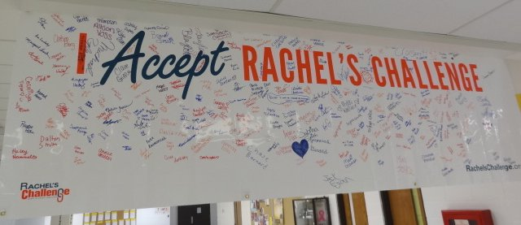

About Rachel’s Challenge
Each day 160,000 students do not go to school because they are bullied, teased and harassed. By turning the story of a tragic death at Columbine High School into a mission for change, Rachel's Challenge is helping create safer learning environments and making a world-wide impact.
Rachel's Challenge is a series of student empowering programs and strategies that equip students and adults to combat bullying and allay feelings of isolation and despair by creating a culture of kindness and compassion. The programs are based on the writings and life of 17-year-old Rachel Scott who was the first student killed at Columbine High School in 1999. Rachel left a legacy of reaching out to those who were different, who were picked on by others, or who were new at her school. Shortly before her death she wrote,
"I have this theory that if one person can go out of their way to show compassion, then it will start a chain reaction of the same. People will never know how far a little kindness can go."
Rachel's Challenge was started by Rachel's dad and stepmom, Darrell and Sandy Scott when they realized that the writings and drawings Rachel left not only had an impact on her friends and classmates, but also resonated with students around the world. Although Rachel was a typical teenager who even wrote about her "ups and downs," she had a passion and conviction that she would someday change the world. The Scott family knew her story and passion had to be told to inspire others to make their world a better place.
More than 19 million people have been touched by Rachel's message, and they continue the legacy of making a difference in their communities. Each year at least 2 million more people are added to that number. These are just a couple of the results of Rachel's Challenge. In one survey, 78% of students indicated they would definitely intervene in a bullying incident in their school after seeing Rachel's Challenge.
The purpose of the elementary programs is to encourage elementary school students to live a life of purpose, do simple acts of kindness and create a KC (Kindness and Compassion) Club to make their school a better place. Stories from Rachel’s life and adaptations of her writings exemplify her belief that small, deliberate acts of kindness could have an impact on the world and a profound effect on those around us. All topics are presented in age-appropriate positive language.
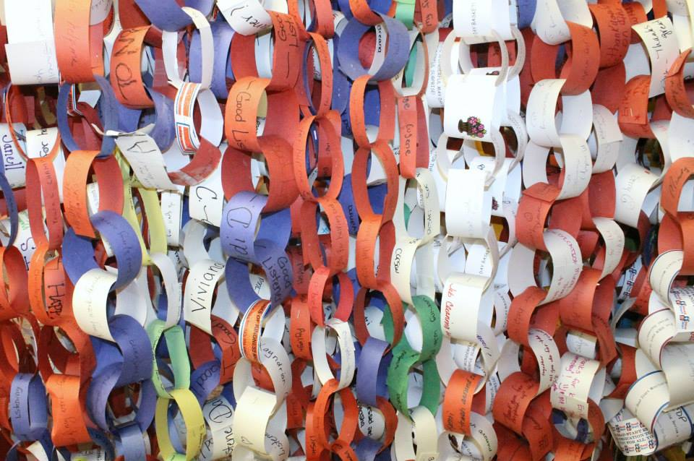
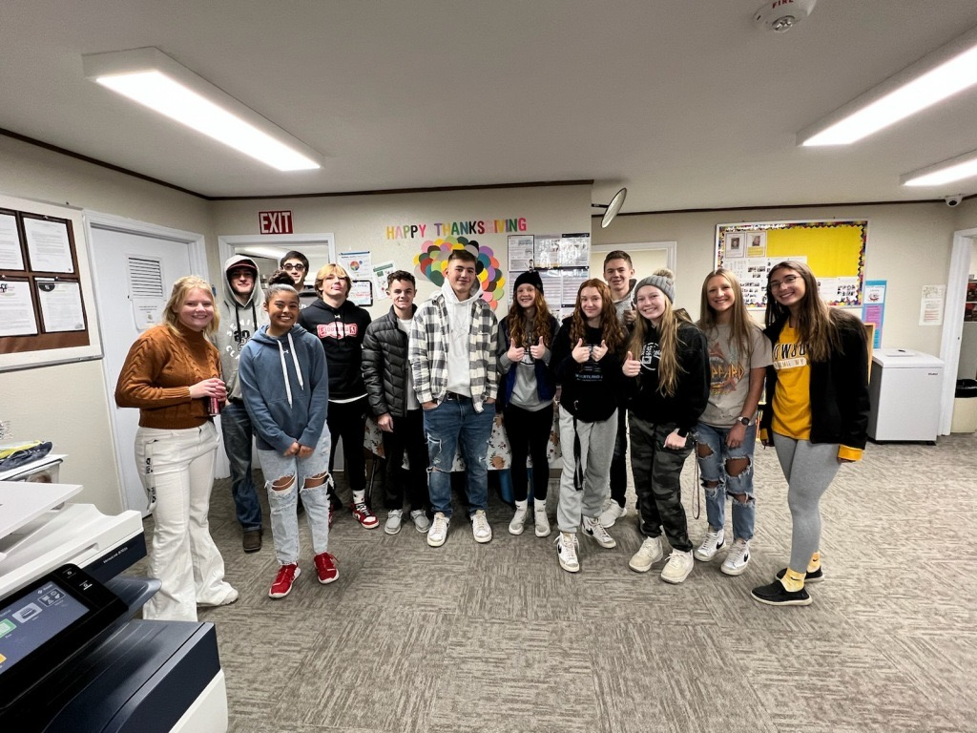

Links of Kindness Ceremony!

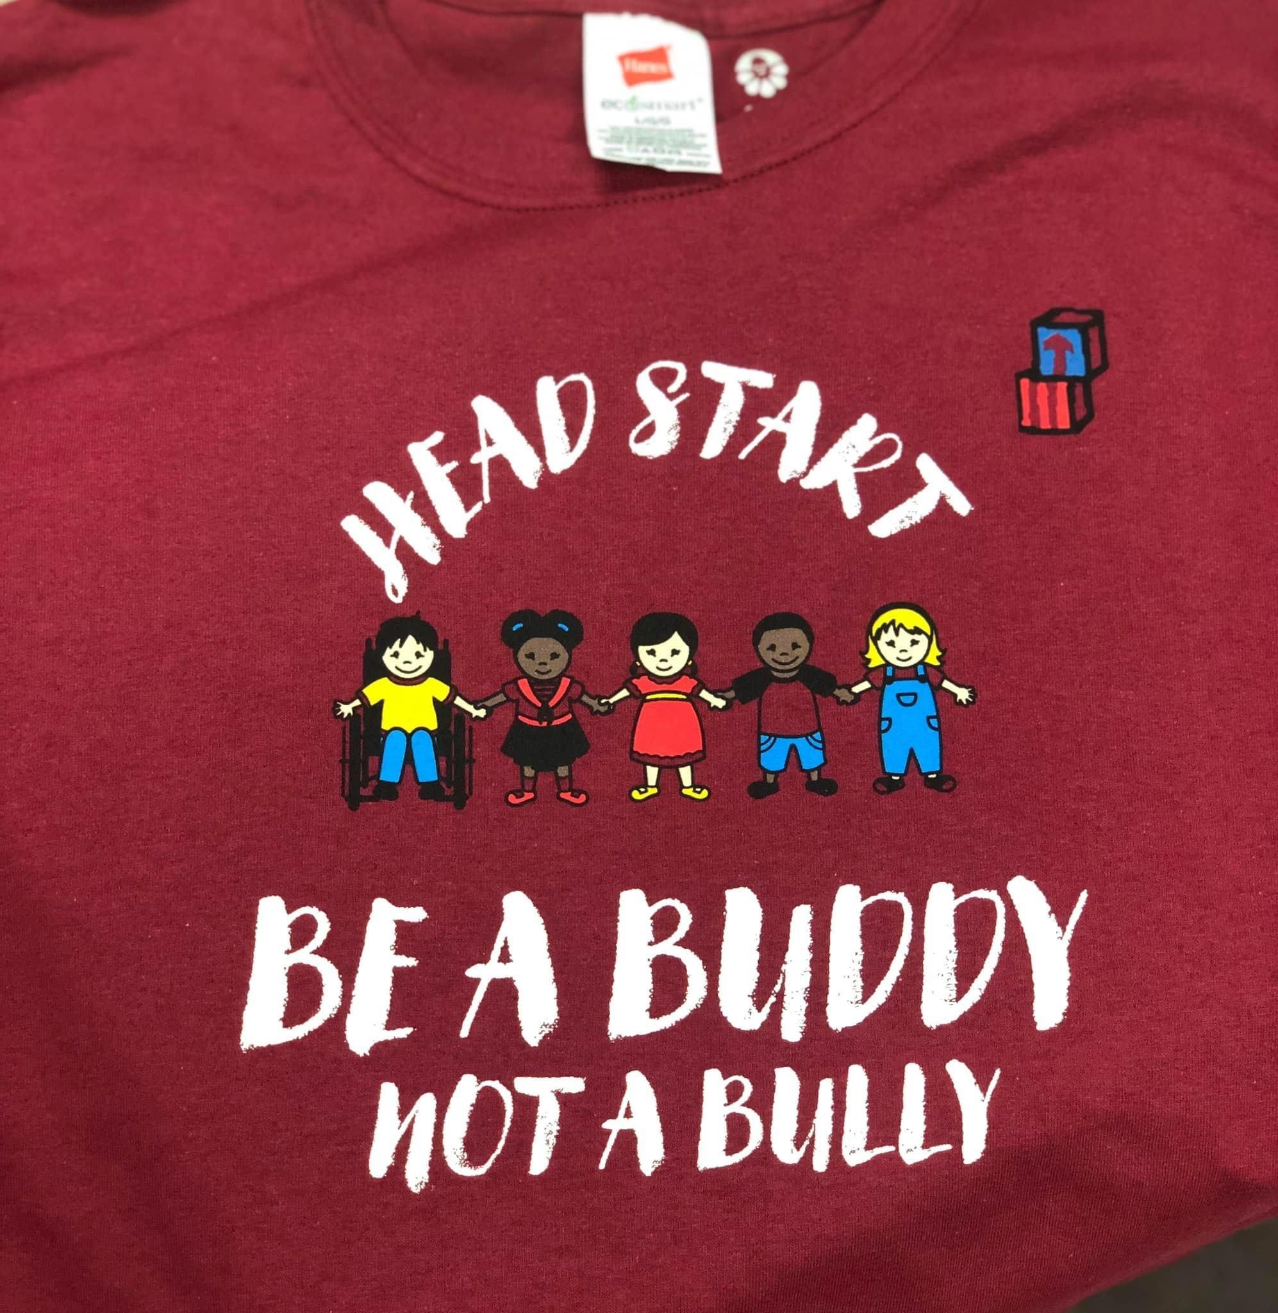

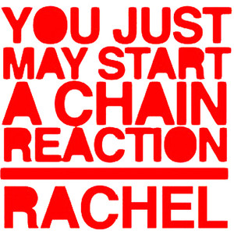


Carbon County Child Development Programs accepted Rachel’s Challenge in 2012 and became one of the first Head Start preschools to take a stand against bullying through Rachel’s Challenge.
At Carbon County Child Development Programs, we teach and practice KINDNESS and COMPASSION through classroom activities, parent and staff trainings, Kindness and Compassion Parent Club, and by giving LINKS of KINDNESS.
We have a goal to become a CULTURE of KINDNESS and to START A CHAIN REACTION!
Kindness, Compassion, Respect Is Best!

Always Be Helpful!

Be A Buddy, Not A Bully!

BUDGET

CCCDP Five Year Grant, Year 3

The budget for the 2022 - 2023 school year was ($1,243,127..00) from Health and Human Services (HHS). The last HHS Federal Review FA1 was conducted in October 2021, and the review identified no findings. The program is on a 5-year grant cycle and will receive an FA2 for the next HHS Federal Review.

The total amount of public and private funds received from each source: City of Rawlins ($8,550.00), WY Quality Counts $300.00, USDA (CACFP) $45,637.56.

The results of the annual audit, conducted by Leo Riley and Company for the period ended October 31, 2022, showed no compliance issues in any area audited.

Five Year Grant Year 4
Budget 2023 - 2024

Budget Category | Head Start Budget Amount
Personnel/Fringe Benefits | 1038515.00
Travel | 500.00
Office Supplies | 15000.00
Classroom Supplies | 5800.00
Medical/Dental Supplies | 2864.00
Parent Activities | 2500.00
Child Food | 7000.00
Kitchen Supplies | 2500.00
Janitorial | 5000.00
Paper Products | 5000.00
Audit | 18000.00
Mental Health | 5000.00
Utilities | 18770.00
Telephone | 8200.00
Building Insurance | 2284.00
Child Liability Ins. | 500.00
Maint./Repair | 15000.00
Vehicle Maint./Repair | 500.00
Vehicle Insurance | 1877.00
Vehicle Operating | 600.00
Local Travel | 200.00
Accounting | 1200.00
Legal | 500.00
Publications | 12250.00
Training/Staff Development | 17476.00
T/TA | 16281.00
Other | 500.00
General Liability Ins. | 15133.00
Theft Bond | 411.00
Tech Support | 20000.00
Criminal Background Check | 266.00
Child Medical/Dental | 500.00
Employee Wellness | 3000.00
Total | 1243127.00

HEALTH
& NUTRITION
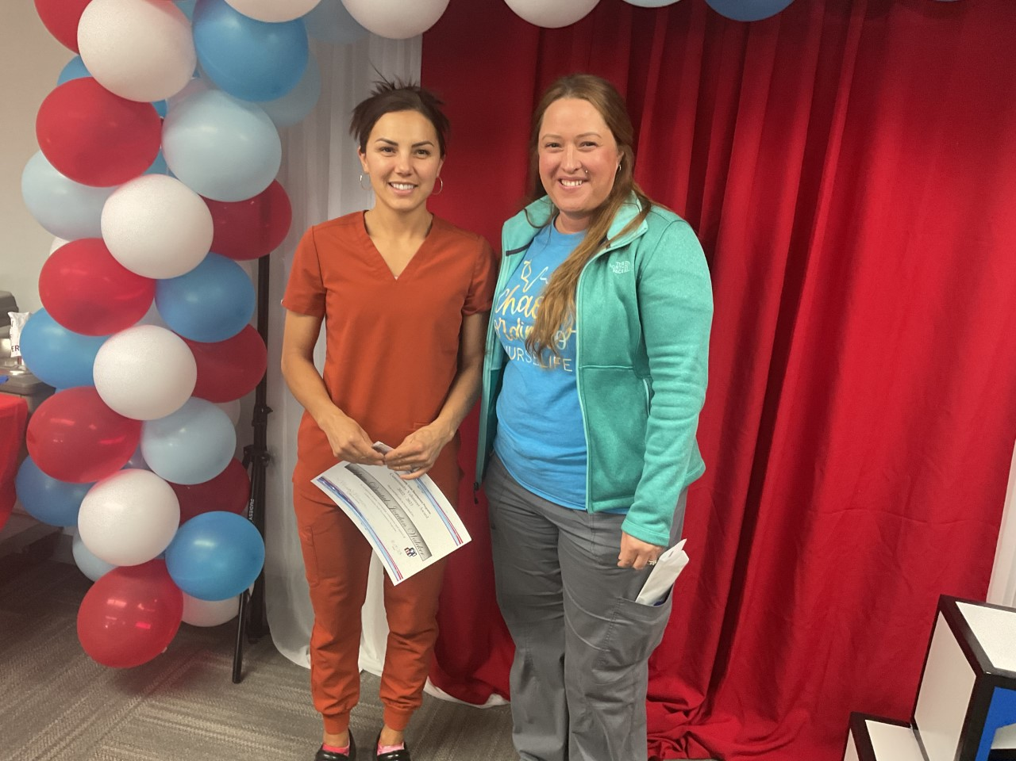

Every child enrolled in the program has the opportunity for required health screenings. Follow-ups are conducted as soon as the initial result is documented. The program’s Health Specialist strives to ensure that medical, dental, vision, nutritional, and mental health services are coordinated in a professional and quality manner. The program Custodian and Safety Officer work hard to keep the building free from hazards and illnesses through
on-going monitoring of safety practices and cleaning efforts.

Number of illnesses within the program year:

COVID exposure: 4
Flu: 3
RSV: 7
Strep: 15
Hand foot & Mouth: 4
Bronchitis: 1 Croup: 1

The percentage of enrolled children that received medical and dental exams:
Medical: 79.17%
59/72
Dental: 81.94%
57/72
58/72 children in the program received fluoride treatment

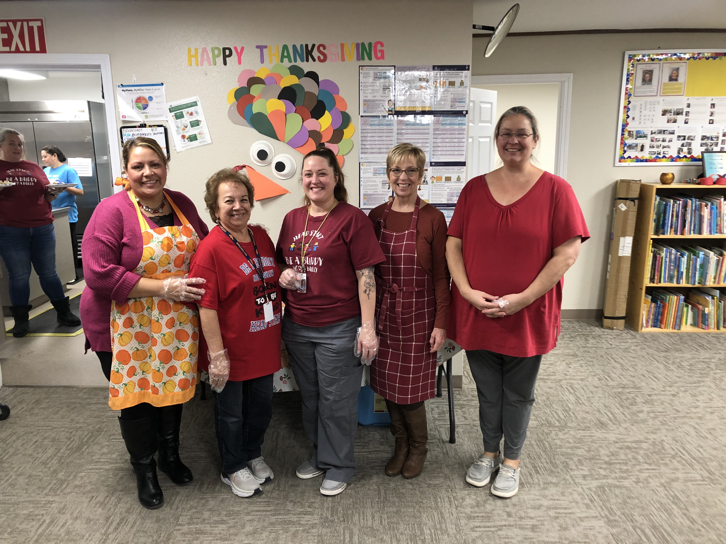

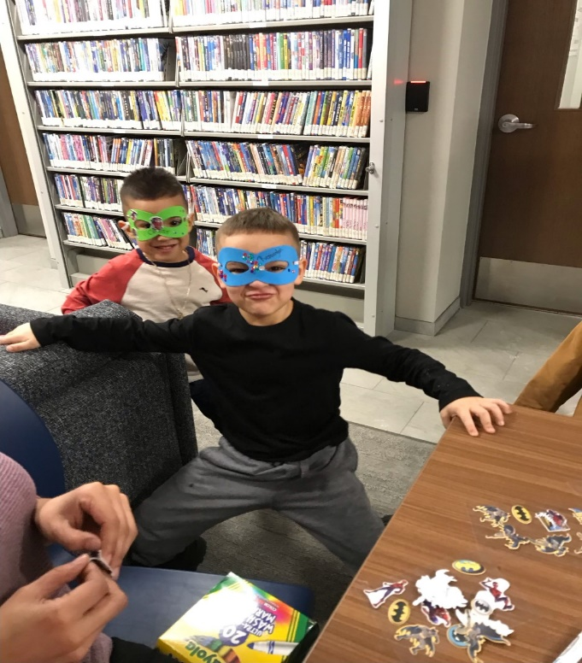

SCHOOL READINESS & CURRICULUM
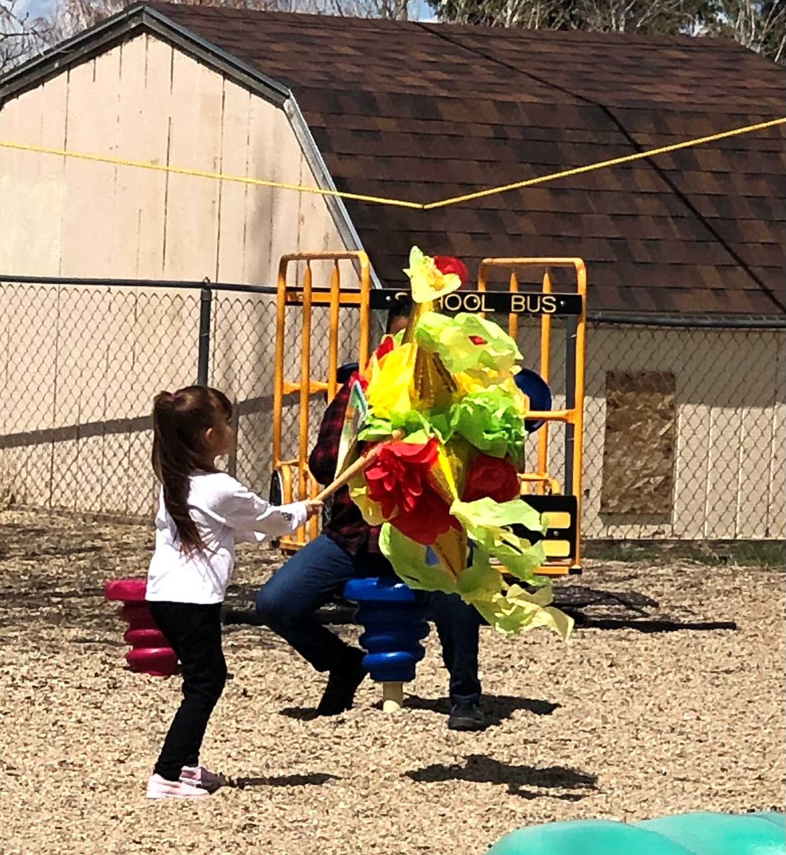

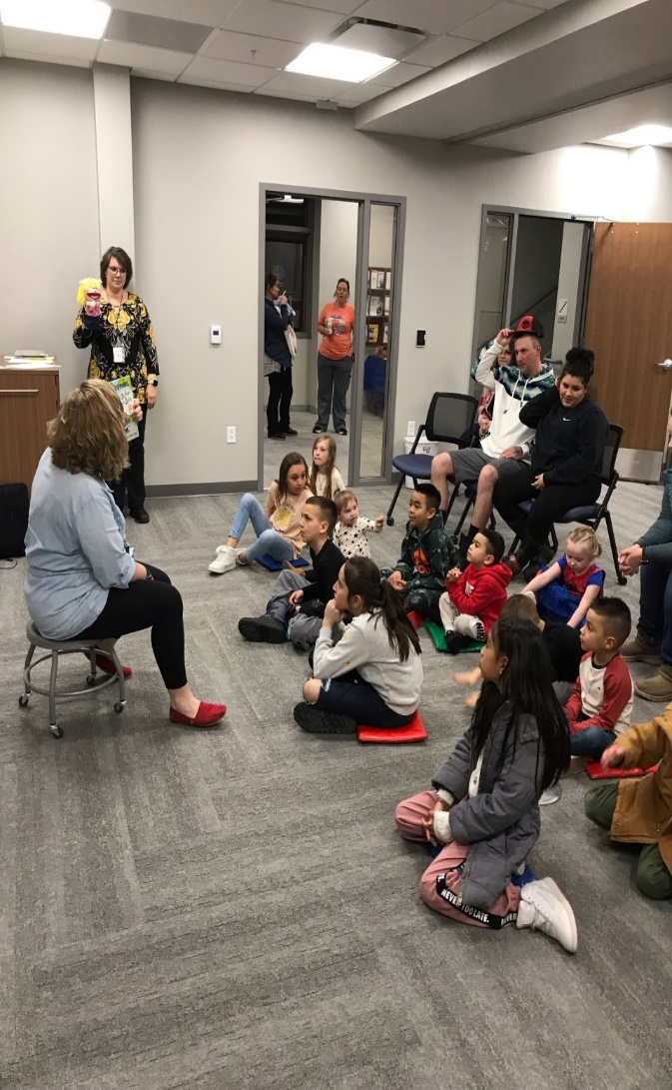



School Readiness
Efforts to prepare children for Kindergarten begin as soon as the child is enrolled in our Head Start program. The center staff, along with parents, review the child’s health and nutrition history, as well as complete the required developmental screening within the first 45 days of enrollment. A Family Partnership Agreement is offered to all families during an initial home or center visit. Follow up visits occur throughout the school year to check on progress of goals and to determine if the family has any needs.
The program’s school readiness team will attempt to meet 2 times throughout the school year. The team consists of program parents, staff, Board and Policy Council members, public school educators, and administrators. The team analyzes and develops data as well as revises the program’s school readiness plan.

Curriculum

The program uses Creative Curriculum as well as supplemental curriculums in all Head Start classrooms. The parent Policy Council approves the curriculum(s) and the children’s progress is tracked using outcomes data available in each developmental area. The program shows an increase in basic cognitive knowledge from the first assessment to the final observations of the children. Children enrolled in CCCDP are better prepared and socially ready to enter Kindergarten and for the challenges of public school. The program works closely with the local school districts to ensure all children have a smooth transition into the public-school system. CCCDP transitioned 35 children to public school. Staff is always available to help and support parents and families with their life long journey of education.

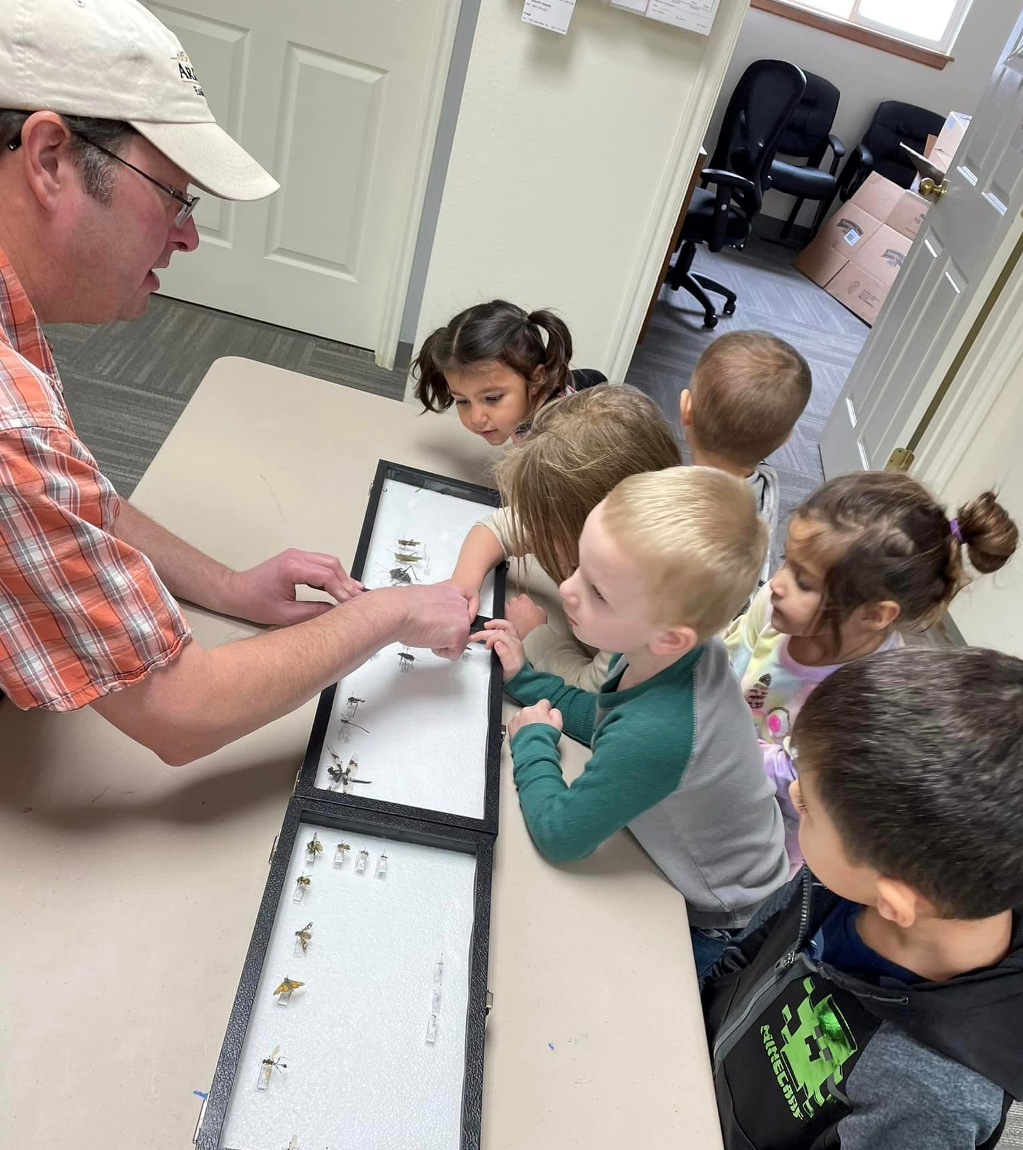

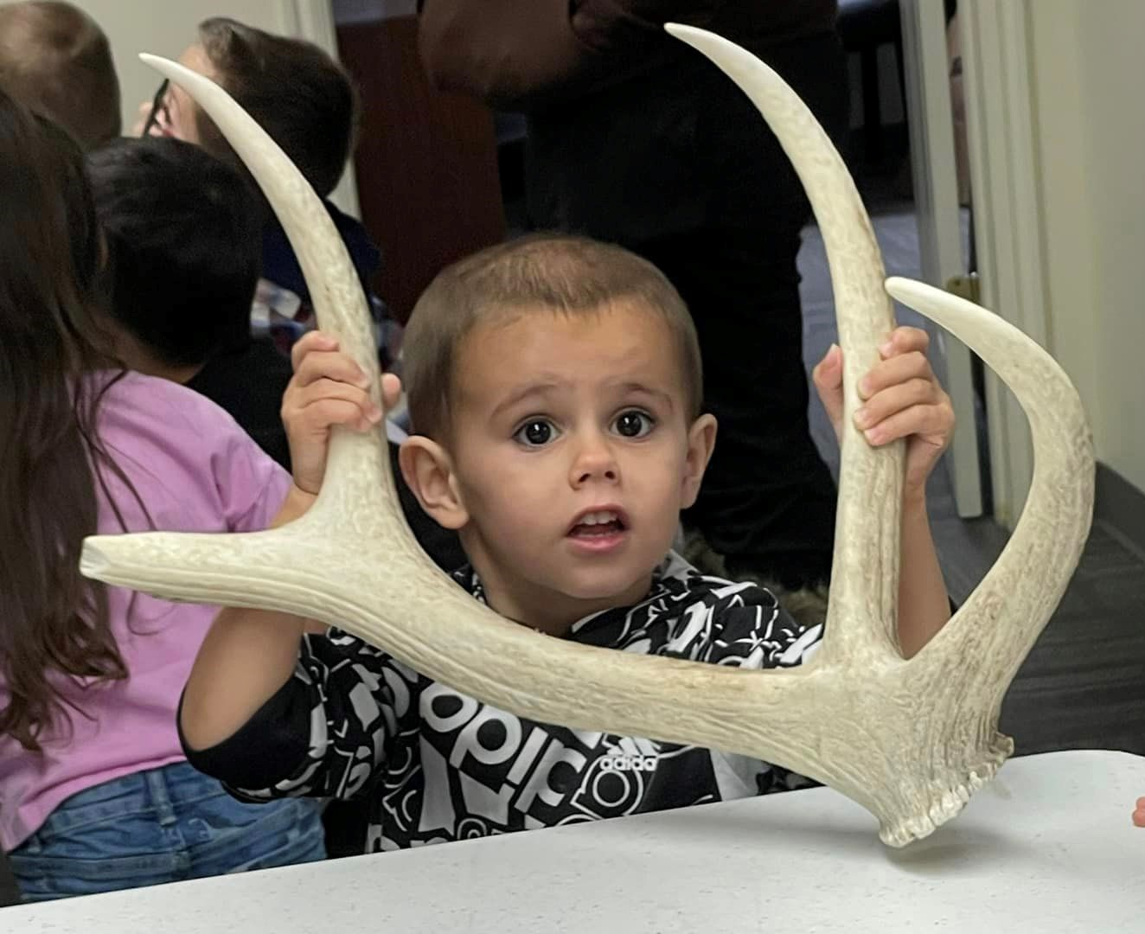

ENROLLMENT & ATTENDANCE

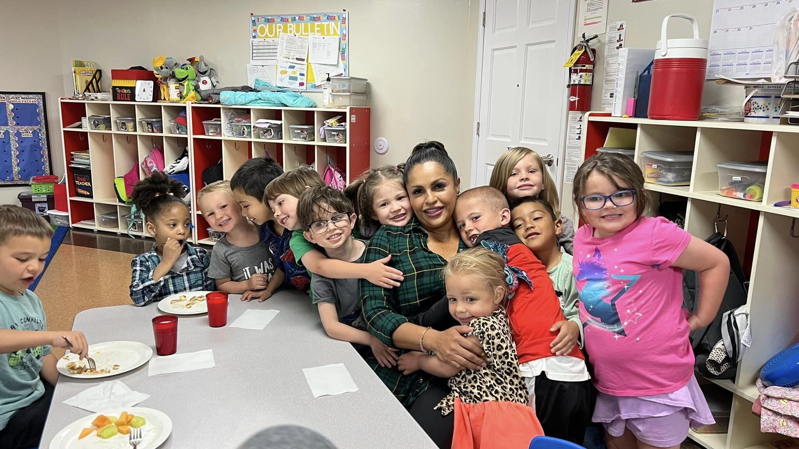

- September 2022: (E) – 57/80 (A) – 88.89%
- October 2022: (E) – 56/80 (A) – 87.92%
- November 2022: (E) – 57/80 (A) – 79.18%
- December 2022: (E) – 61/80 (A) – 80.82%
- January 2023: (E) – 61/80 (A) – 80.13%
- February 2023: (E) – 58/80 (A) – 83.53%
- March 2023: (E) – 62/80 (A) – 80.91%
- April 2023: (E) – 62/80 (A) – 83.67%
- May 2023: (E) – 61/80 (A) – 86.34%

Monthly Enrollment (E) (Funded enrollment 80) and
Attendance (A) Data 2022 - 2023

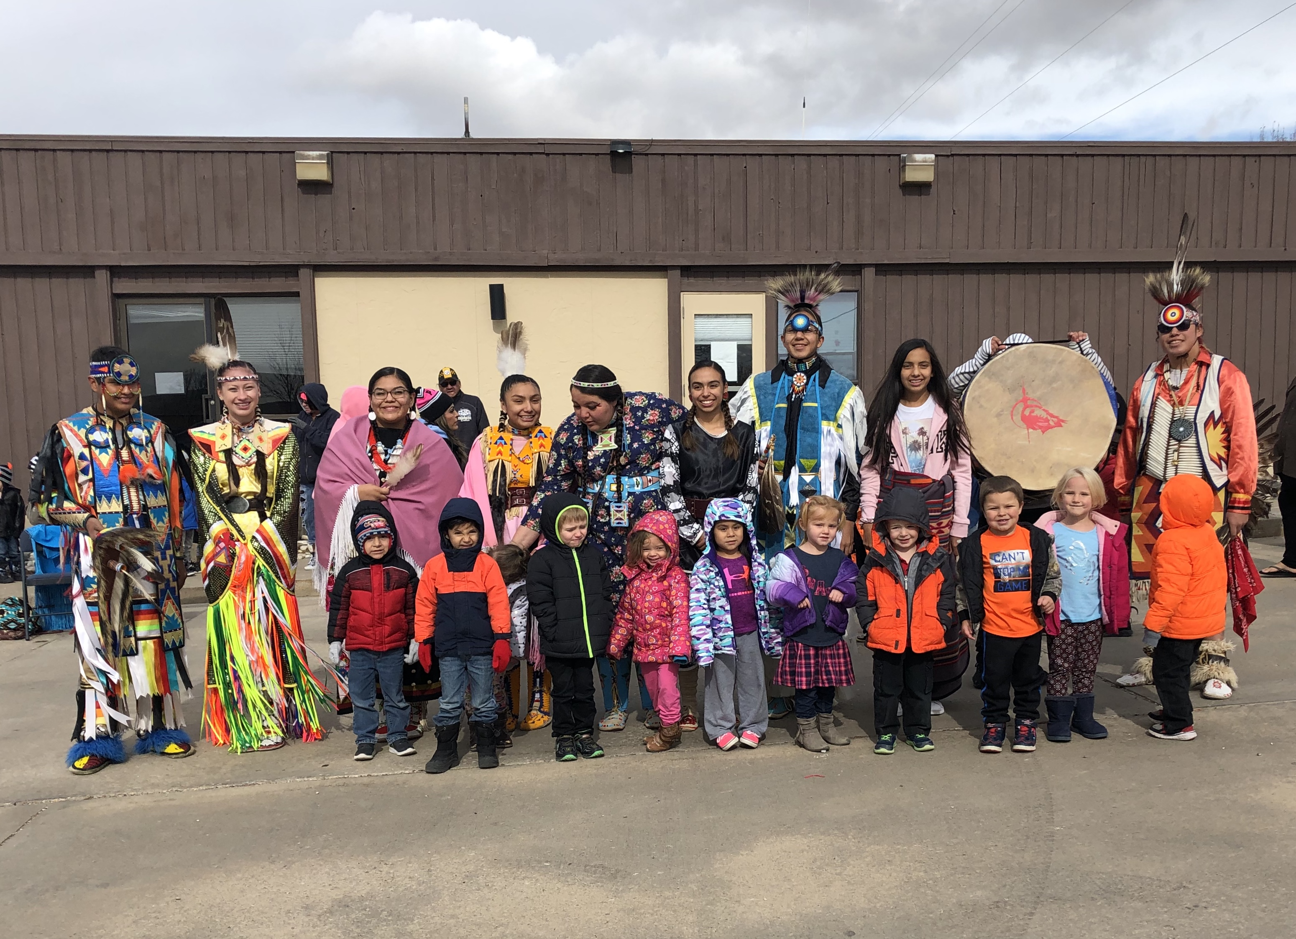

FAMILIES
&
VOLUNTEERS
“Volunteers do not have more time - they just have more heart.” -Anonymous
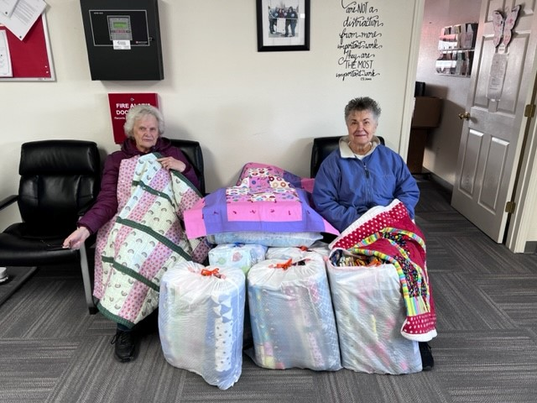

Carbon County Quilters makes a quilt for each child in the program every year. They volunteer their time make sure each child has a blanket at school.

Parent Engagement & Activities
CCCDP conducts, at a minimum, one parent/family activity per month. The program provides meals whenever possible for parent meetings. Various activities include book distributions, fatherhood activities, literacy training, as well as parenting classes. Fall Fest and other family activities are well received, as well as classes on keeping your child healthy and well-fed on a budget. The parents are the drive behind the activities and their wishes for the program are scheduled when possible. Appropriate trainers and speakers are commissioned as necessary. The program is always looking for new and exciting ways to get parents involved in their child’s education.

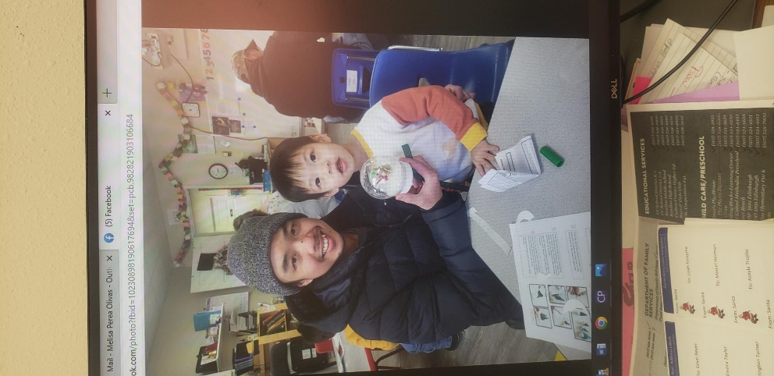
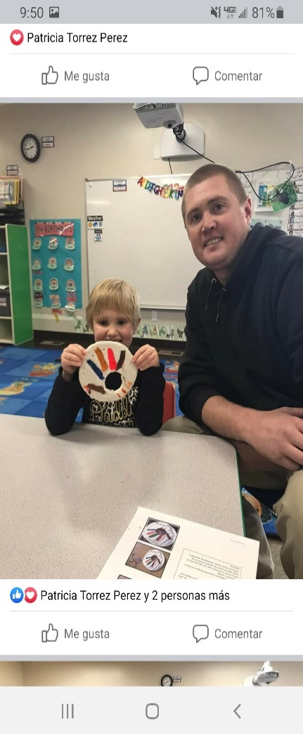

Head Start programs like Carbon County Child Development rely heavily on parent and community volunteers and donations to make a difference in a Head Start child’s life, as well as provide services to the program. Head Start provides 80% of annual program costs, while 20% of the annual program costs must be provided by community donated goods and services.

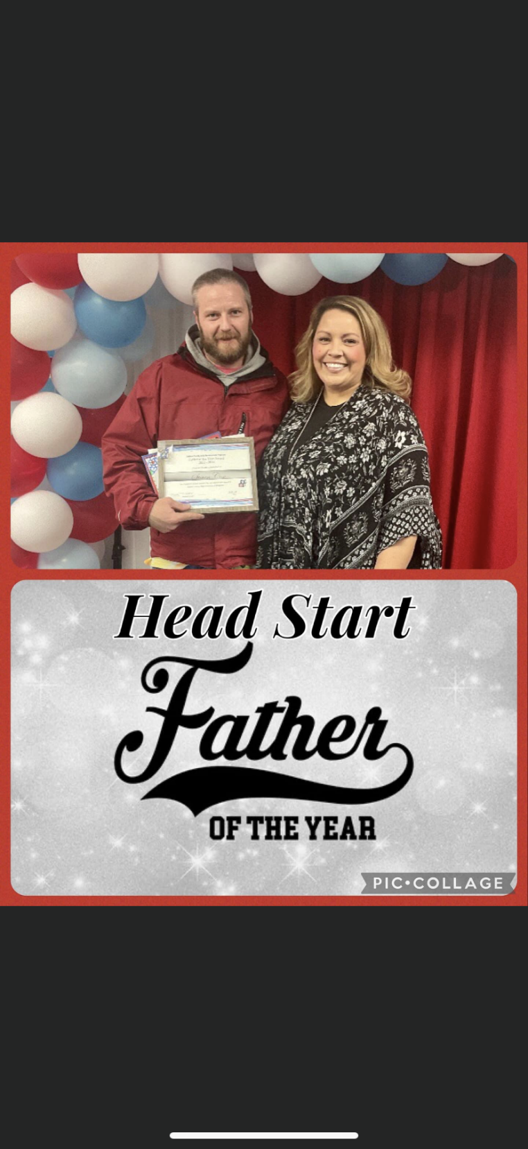

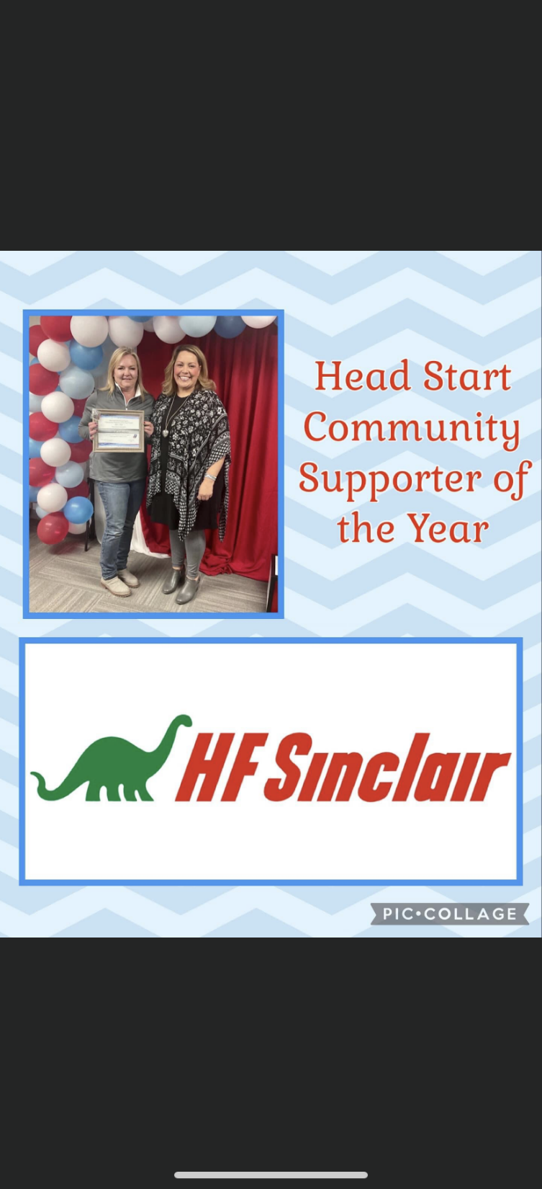

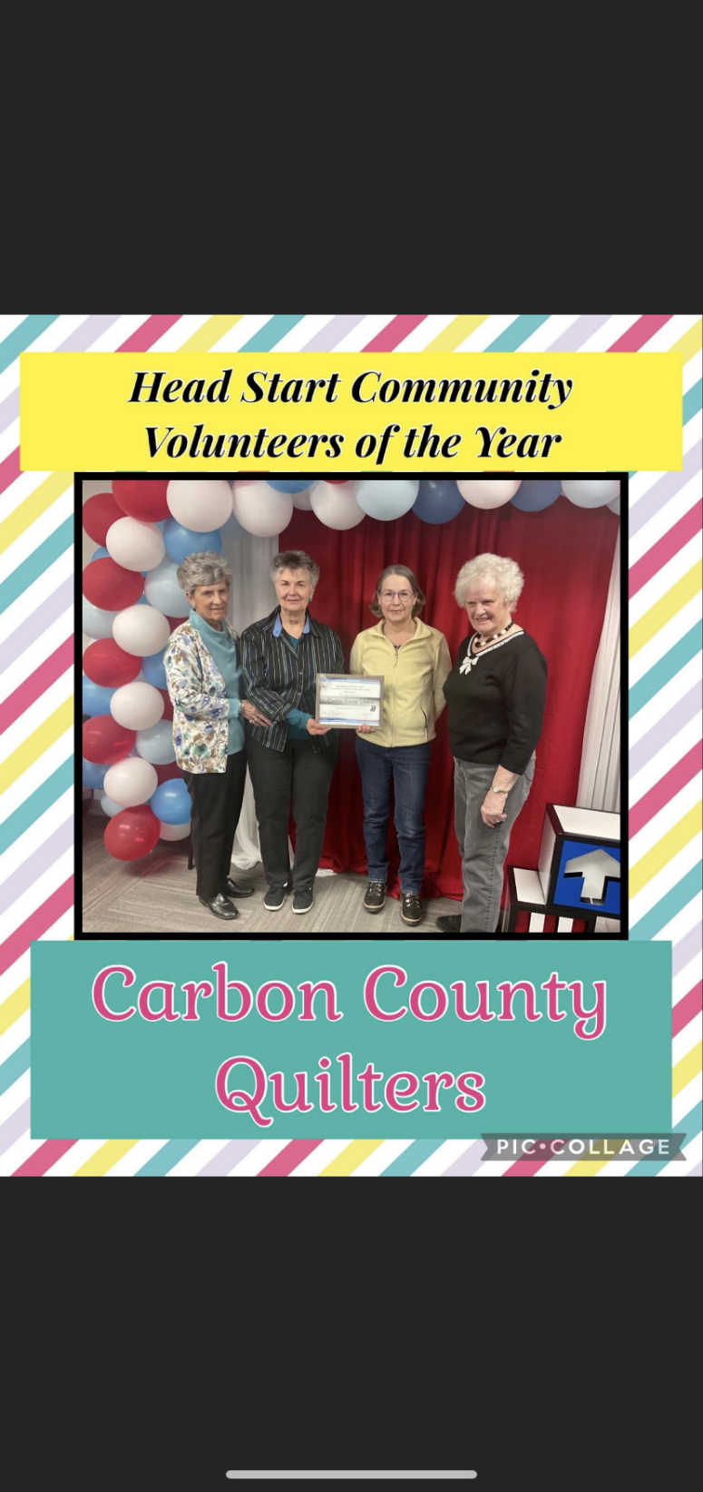


CARBON COUNTY CHILD DEVELOPMENT PROGRAMS
Family Engagement
Family Partnership Agreements: Out of the 65 families served at Carbon County Child
Development Programs (CCCDP), 78 family partnership agreements were completed with
100% engagement.
- Referrals: Families were referred to the following agencies:
WIC: 10 Food Banks: 2 Legal Assistance: 3 Doctor: 1 Dentist: 3 GED/HISET: 6
LIEAP: 1 ESL: 3 Transportation: 3
Mental Health: 3 WYO Help: 16 Salvation Army: 7
- Reading challenges: 43% of CCCDP families participated in the monthly reading challenges with a total of 129 books sent home.
- Fatherhood Initiatives: 66% of male figures participated in activities like winter snow globes, pumpkin painting, Leprechaun hats, and popsicle bird feeders.
- Parent Center: 26% of CCCDP parents attended parent center committee and made decisions regarding fatherhood activities, reading challenges, events like Literacy Night, Financial Enrichment Classes, and many others.
- Family goals: Some examples of family goals set with CCCDP families were: transition to kindergarten, leadership, reading, education, nutrition, mental health, and program & community engagement.
- Out of 32 families that set up a transition to kindergarten goal, 24 families achieved their goal.
- Out of 17 families that set up a reading goal, 10 families achieved their goal.
- Out of the 2 families that set up a financial goal, both achieved this goal.
- Out of the 8 families that set up a leadership goal, 6 achieved their goal.
- Out of the 3 families that set up an education goal, 3 achieved their goal.
- Out of the 13 families that were homeless at the beginning of enrollment, 8 acquired housing at the end of the school year.

COMMUNITY ENGAGEMENT

Every year CCCDP staff works hard during the holidays to make sure there are no Head Start families that will go without food or toys for their children. The program’s strong partnerships with our community members are what make it possible. As a result, we were able to provide the following listed below:
- 7 families in the program were sponsored by community partners like: Coldwell Banker, Carbon County Higher Education Center, Smith Family, and Craig Morgan.
- 27 families with a total of 77 children were helped with Christmas gifts through Elks Lodge 609.
- All Head Start children were provided with a gift from the CCCDP Angel Tree.
- 32 Thanksgiving food baskets were provided.
- 32 Christmas food baskets were provided.
- During the holidays, a turkey was provided for each Head Start family in the program, sponsored by HF Sinclair.

Families in Crisis: Unlike previous years, we had an increase of families in need. Through the Head Start family relief fund, we were able to assist families with rental deposit, 2 phone cards, 2 car seats, diapers, 6 coats, jackets, shoes, and winter boots, just to mention a few.

Every year we hold Literacy Night at the Carbon County Library for Head Start families. We provide education, crafts, puppets, bonding time, and fun for our attendees.

Financial struggles are part of everyday stressors, our families were offered financial education opportunities through H & R Block, Bank of Commerce, and Edward Jones.

SURVEY RESULTS: The opinions of our families are very important to the program and we try our hardest to make sure their voices are heard. Here are some highlights of what they shared with us:
100% I feel safe when I leave my child in the program.
100% I am satisfied with the meals served to my children.
100% I have made positive changes in my life as a result of the goal set up process with my family advocate.
100% I feel empowered to advocate for my own child’s education.
100% Head Start provides a clean environment for my child.

SUPERHERO LITERACY NIGHT: We hosted this fun event at the Carbon County Library. We had a participation of 10 families with a total of 35 people in attendance and served as an opportunity to strengthen our community partnership with Carbon County Library. Families enjoyed puppets, bingo for books, family prizes, pizza, and drinks. Children had the choice to dress up as their favorite superhero character and take family pictures. Parents received tips and best practices on how to make their kids fall in love with reading!

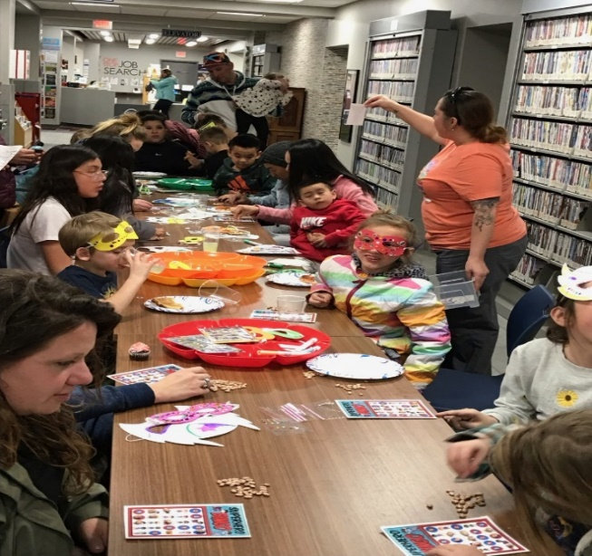
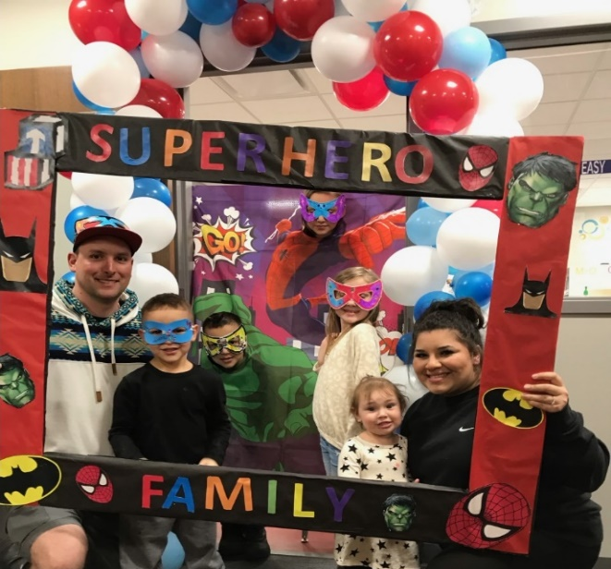

FATHERHOOD INITIATIVE
2022-2023
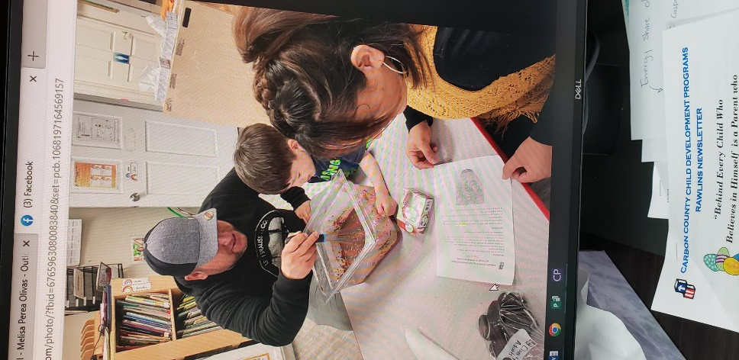
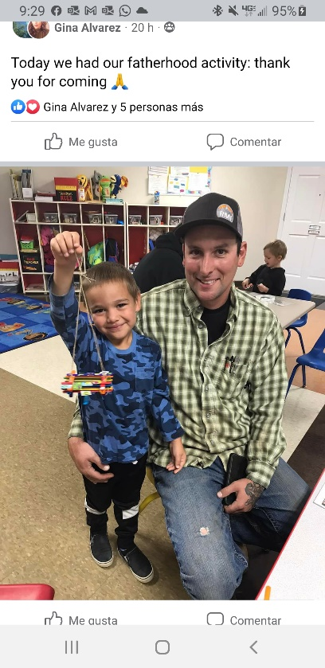

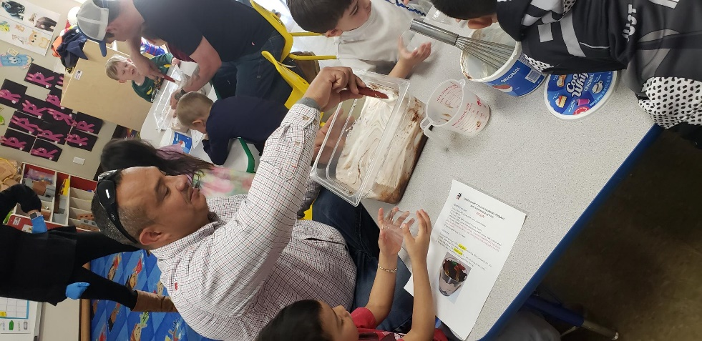

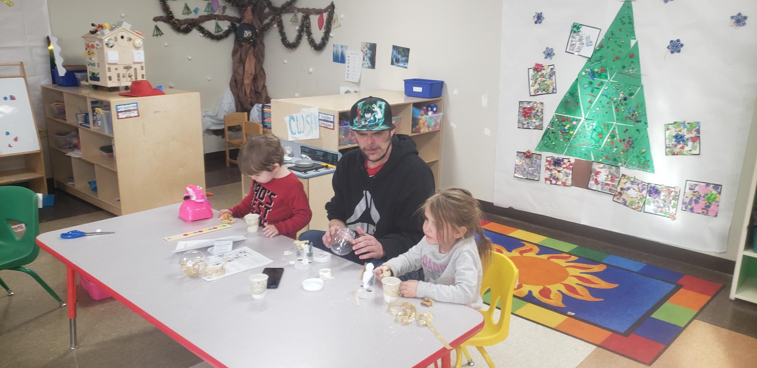
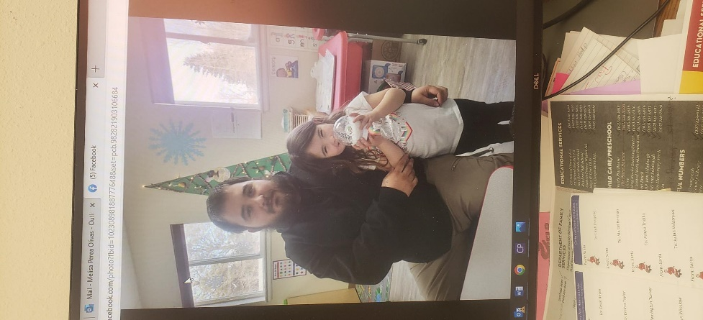

Average monthly enrollment as a percentage of funded enrollment is 74.3%. The percentage of income eligible children served is 90%.

History and Background

CCCDP has been a part of the Rawlins community since 1965. It started in 1965 under CAP (Community Action Program) as an eight-week summer program. The program was incorporated in 1971 as Carbon County Child Development Programs.

The program includes Head Start preschool programs in two Carbon County locations: Rawlins and Saratoga. Each site is unique to the area and population. These programs are dedicated to providing children and families the opportunity to live resourceful, equitable and dignified lives.

CCCDP employs 27 to 30 employees annually. The program teachers strive to have at a minimum an Associate Degree in Early Childhood Education or related field, with 50% of the teachers in the program with or working towards a Bachelor Degree in Early Childhood Education. The Paraprofessionals are encouraged to be enrolled as degree seeking students in classes that will result in an Associate Degree or in a Child Development Program (CDA). CCCDP works closely with the County Developmental Disabilities Program to provide special education services when necessary. When necessary, the program will apply for approved waivers for staff who do not meet the credential qualifications. A professional development plan will be completed for all teaching staff.

In accordance with federal civil rights law and U.S. Department of Agriculture (USDA) civil rights regulations and policies, this institution is prohibited from discriminating on the basis of race, color, national origin, sex (including gender identity and sexual orientation), religious creed, disability, age, political beliefs, or reprisal or retaliation for prior civil rights activity.

"We find delight in the beauty and happiness of children that makes the heart too big for the body."
~Ralph Waldo Emerson

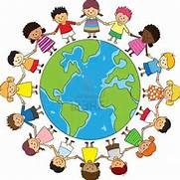

Carbon County Child Development Programs
1705 and 1801 Edinburgh
Rawlins, WY 82301
(307) 324-4951 and (307) 324-9571

Saratoga Head Start
Center Supervisor – Pat Forbes
1114 Saratoga Ave.
Saratoga, WY 82331
(307) 326-5056

Executive Director: Mindy Monson

